Copied the csv file to ec2-instance



Used cut command to extract the specific column

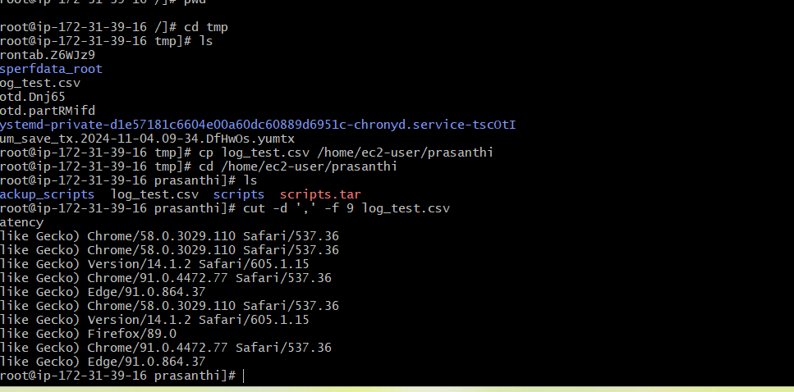

Code and output

